**EDGE PROGRAM PROJECT -Vehicle Rental System**

**Identifying required Entities** : identifying attributes and primary key for each entity:

* **Users** • user_id (PK)
* first_name
* last_name
* email
* phone
* address
* driver_license_number

# • Vehicles

* vehicle_id (PK)
* make
* model
* year
* vin
* registration_number
* status
* type_id (FK)

# • Vehicle_Type

* type_id (PK)
* type_name

# • Rentals

* rental_id (PK)
* user_id (FK)
* vehicle_id (FK)
* rental_date
* return_date
* total_amount

# • Payments

* payment_id (PK)
* rental_id (FK)
* payment_date
* amount
* payment_method

# • Reservations

* reservation_id (PK)
* user_id (FK)
* vehicle_id (FK)
* reservation_date
* status

# • Vehicle_Maintenance

* maintenance_id (PK)
* vehicle_id (FK)
* maintenance_date
* details
* cost
* **Locations** • location_id (PK)
* location_name
* address
* phone

# • Vehicle_Location

* vehicle_location_id (PK)
* vehicle_id (FK)
* location_id (FK)
* date_moved

# Reviews

* review_id (PK)
* user_id (FK)
* vehicle_id (FK)
* review_date
* rating
* comments

**Identifying the required relationship;**

* **Users** to **Rentals**: One-to-Many
* One user can have multiple rentals.
* Foreign Key: user_id in Rentals references user_id in Users.

# • Users to Reservations: One-to-Many

* One user can have multiple reservations.
* Foreign Key: user_id in Reservations references user_id in Users.
* **Users** to **Reviews**: One-to-Many
* One user can write multiple reviews.
* Foreign Key: user_id in Reviews references user_id in Users.
* **Vehicles** to **Rentals**: One-to-Many
* One vehicle can be rented multiple times.
* Foreign Key: vehicle_id in Rentals references vehicle_id in Vehicles.

# • Vehicles to Reservations: One-to-Many

* One vehicle can have multiple reservations.
* Foreign Key: vehicle_id in Reservations references vehicle_id in Vehicles.

# • Vehicles to Vehicle_Maintenance: One-to-Many

* One vehicle can have multiple maintenance records.
* Foreign Key: vehicle_id in Vehicle_Maintenance references vehicle_id in Vehicles.

# • Vehicles to Vehicle_Location: One-to-Many

* One vehicle can have multiple location records over time.
* Foreign Key: vehicle_id in Vehicle_Location references vehicle_id in Vehicles.

# • Vehicle_Type to Vehicles: One-to-Many

* One vehicle type can be assigned to multiple vehicles.
* Foreign Key: type_id in Vehicles references type_id in Vehicle_Type.

# • Locations to Vehicle_Location: One-to-Many

* One location can have multiple vehicle location records.
* Foreign Key: location_id in Vehicle_Location references location_id in Locations.
* **Rentals** to **Payments**: One-to-Many
* One rental can have multiple payments.
* Foreign Key: rental_id in Payments references rental_id in Rentals.

**ERD Diagram**

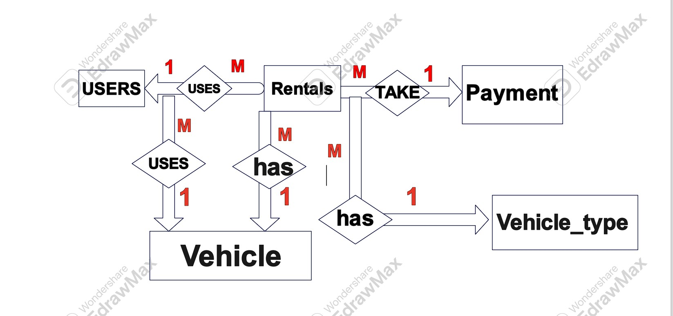

**Reducing diagram to schema**:

**Users** (user_id, first_name, last_name, email, phone, address, driver_license_number)

**Vehicles** (vehicle_id, make, model, year, vin, registration_number, status)

**Vehicle_Type** (type_id, type_name)

**Rentals** (rental_id, user_id (FK), vehicle_id (FK), rental_date, return_date, total_amount) **Payments** (payment_id, rental_id (FK), payment_date, amount, payment_method)

**Reservations** (reservation_id, user_id (FK), vehicle_id (FK), reservation_date, status)

**Vehicle_Maintenance** (maintenance_id, vehicle_id (FK), maintenance_date, details, cost)

**Locations** (location_id, location_name, address, phone)

**Vehicle_Location** (vehicle_location_id, vehicle_id (FK), location_id (FK), date_moved)

**Reviews** (review_id, user_id (FK), vehicle_id (FK), review_date, rating, comments)

* review_id (PK)
* user_id (FK)
* vehicle_id (FK)
* review_date
* rating
* comments